INTRO TO NUMPY
What is NumPy?
- NumPy is a Python library used for working with arrays.
- It also has functions for working in domain of linear algebra, Fourier transform, and matrices.
- NumPy was created in 2005 by Travis Oliphant. It is an open-source project and you can use it freely.
- NumPy stands for Numerical Python.
Why Use NumPy?
- In Python we have lists that serve the purpose of arrays, but they are slow to process.
- NumPy aims to provide an array object that is up to 50x faster than traditional Python lists.
- The array object in NumPy is called ndarray, it provides a lot of supporting functions that make working with ndarray very easy.
- Arrays are very frequently used in data science, where speed and resources are very important.
Why is NumPy Faster Than Lists?
- NumPy arrays are stored at one continuous place in memory unlike lists, so processes can access and manipulate them very efficiently.
- This behaviour is called locality of reference in computer science.
- This is the main reason why NumPy is faster than lists. Also it is optimized to work with latest CPU architectures.
Which Language is NumPy written in?
- NumPy is a Python library and is written partially in Python, but most of the parts that require fast computation are written in C or C++.
OPERATIONS:
#Creating arrays
arry1 = np.array([1, 2, 3, 4, 5, 6, 7, 8, 9, 10, 11]) #1d array
arry2 = np.array([[4, 5, 6], [7, 8, 9]]) #2d array
arry3 = np.array([[[1, 2, 3], [4, 5, 6], [7, 8, 9], [10, 11, 12]]]) #3d array
arry4 = np.array([1, 2, 3, 5, 9], ndmin=4) #4d array
# Numpy version and data types
version = np.__version__
print("Numpy Version:", version)
print("Type of Array1:", type(arry1))
# Checking dimensions
print("Dimensions of arry1:", arry1.ndim)
# Accessing elements
print("Element at index 2 in arr1:", arr1[2])
# Negative indexing
print("Last Element from 2nd row in arry2:", arry2[1, -1]) # prints from last
# Slicing arrays
print("Slicing Arrays:")
sliced_array = arry1[2:5]
print("Original Array:", arry1)
print("Sliced Elements from arry1 (index 2 to 4):", sliced_array)
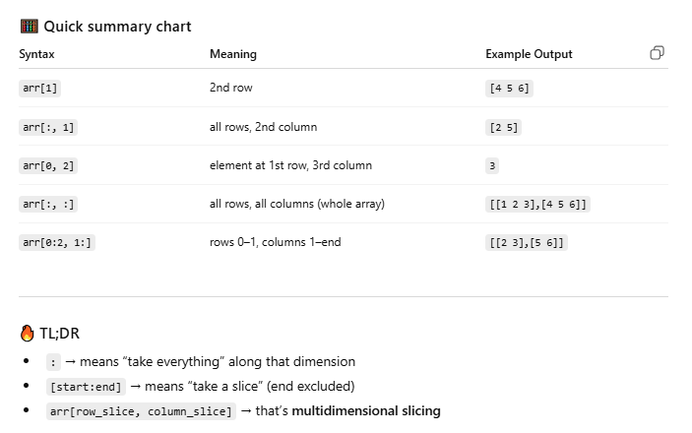
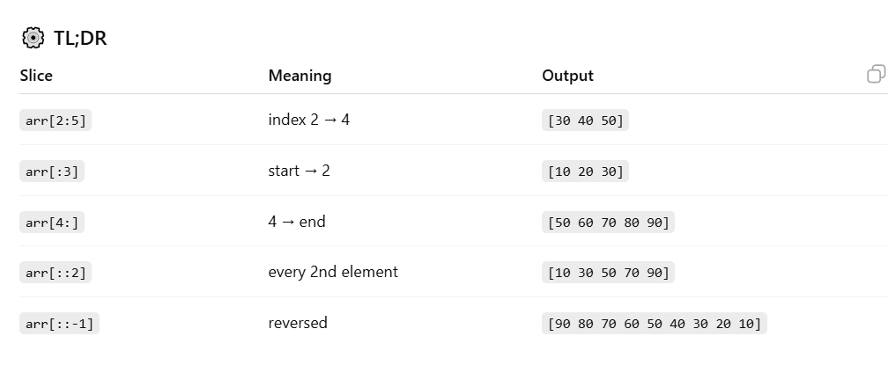
OPERATIONS ON NUMPY
# Finding datatype:
arr=np.array(['apple','banana','pineapple','grapes']) # >U9
arr1=np.array([1.2,2.31,4.56,3.1456]) #float64
arr2=np.array([1,2,6,5,8]) #int64
arr3=np.array(['a','b','c','d','e','f']) # >U1
print(arr.dtype)
# changing from one data type to another
newarr=arr1.astype('int') #float originally
print("og array:",arr1)
print(arr1.dtype) #converted to int
print("as int:",newarr)
print(newarr.dtype)
# View and copy
arr2_copy=arr2.copy()
arr2_view=arr2.view()
arr2[2]=3
print(arr2_copy)
print(arr2_view)
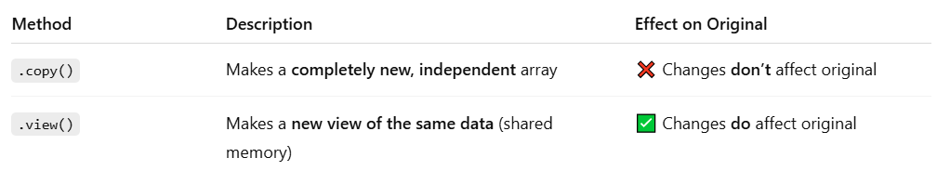
# Shaping and reshaping
- “Shape” in NumPy tells you how many dimensions your array has and how many elements are in each.
arr = np.array([[1, 2, 3], [4, 5, 6]])
print(arr.shape) # (2, 3)

- Reshaping means changing the structure of the array without changing its data.
arr = np.array([1, 2, 3, 4, 5, 6])
reshaped = arr.reshape(2, 3)
print(reshaped)
op:
[[1 2 3]
[4 5 6]]

# Splitting
arra=np.array([1,2,3,4,5,6])
print(arra)
split=np.array_split(arra,2)
for half in split:
print(half)

